- Define Arithmetic mean.
ALLIED STATISTICS I QUESTION BANK UNIT III
2 MARKS

It is defined as the sum of the values of all individual observation of a series divided by the number of observations of a series.
- Define median
Median is the value which divides the distribution into two halves.
- Define mode.
Mode is the value which occurs most often in the data.
- Write the properties of a good average.
  - It should be based on all observations
  - It should not be affected by extreme observations
- Write the emphrical relationship formula
Mode = 2 Mean – 3 Median
- Write the two mathematical properties of mean. Sum of deviations from mean is zero.
Sum of the squared deviations taken from mean is always less than that of the squared deviations taken from any other value.
- Write the formula for combined arithemetic mean

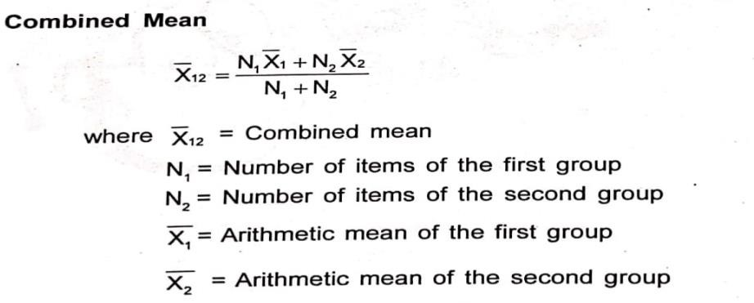
- How median is calculated in raw data
For a small data set, you first count the number of data points (n) and arrange the data points in increasing order. If the number of data points is uneven, you add 1 to the number of points and divide the results by 2 to get the rank of the data point whose value is the median..
- When mode is said to be ill defined.
In case there are two values of variable which have equal highest frequency, then the series is bi-modal and mode is said to be ill-defined.
- Name the types of average.
Arithmetic mean,Median, Mode ,Geometric mean and Harmonic mean.
- Write the two merits of mean.
- It is rigidly defined, simple, easy to understand and easy to calculate.
- It is based upon all the observations.
- Write the two demerits of mean.
It cannot be determined by inspection nor it can be located graphically.
(ii) Arithmetic mean cannot be used for qualities characteristics such as intelligence, honesty, beauty etc.
- Write the two merits of median. It can be located graphically.
For open end intervals, it is also suitable one. As taking any value of the intervals, value of Median remains the same.
- Write the two demerits of median.

It is affected much more by fluctuations of sampling than A.M. Median cannot be used for further algebraic treatment.
- Write the two merits of mode.
- It can be easily understood and is easy to calculate.
- It can be measured even if open - end classes and can be represented graphically.
- Write the two demerits of mode.
- It is not capable of further algebraic treatment.
- It is not rigidly defined measure.
- Write the uses of mean.
It is used for calculating average marks obtained by a student.
if we would like to know how many hours on average an employee spends at training in a year, we can find the mean training hours of a group of employees.
- Write the uses of median.
he median is often used as a measure of central tendency for income distributions, which are generally highly skewed.
- Write the uses of mode.
Mode is the average to be used to find the ideal size, e.g., in business forecasting, in manufacture of ready-made garments, shoes etc.
- Define quartiles
Quartiles are three values that split sorted data into four parts, each with an equal number of observations. First quartile: Also known as Q1, or the lower quartile. Second quartile: Also known as Q2, or the median. Third quartile: Also known as Q3, or the upper quartile.
- Define deciles.
Decile is that divides the dataset into 10 equal subsections with the help of 9 data points.
- Define percentiles.
Percentiles are values that divide a set of observations into 100 equal parts.

- Define geometric mean
The Geometric Mean (G.M) of a series containing n observations is the nth root of the product of the values.
- Define Harmonic mean
The harmonic mean is a numerical average calculated by dividing the number of observations, or entries in the series, by the reciprocal of each number in the series.
5 MARKS
- Find the mean, median, mode, geometric mean and harmonic mean for the following data

82 | 93 | 50 | 54 | 72
- Find the mean, median and mode for the following data.

Life Span  Years | 4-6 | 6-8 | 8-10 | 10-12 | 12-14
No. of  bulbs | 10 | 17 | 32 | 21 | 40
- What are the requisites of a good average.
- Explain in detail about grouping and analysis table to determine mode.
- Write the mathematical properties of arithmetic mean.
- Find the Median for the following data

Class | 0-10 | 10-20 | 20-30 | 30-40 | 40-50 | 50-60 | 60-70
Frequency | 8 | 20 | 34 | 46 | 28 | 14 | 10
- Explain how is mode is determined graphically.
- Explain the merits and demetrits of geometric mean
10 Marks
- Compute Mean, Median and Mode for the following data given below

Expenditure  (Rs.) | 160 | 200 | 250 | 320 | 410 | 500 | 570
No. of  families | 5 | 12 | 23 | 18 | 13 | 8 | 3
- Write the merits and demerits of mean

- Write the merits and demerits of median
- Write the merits and demerits of mode
- Write the procedure to determine median graphically.
- Explain the merits and demerits of harmonic mean

